PETROLIMEX INFORMATION TECHNOLOGY

AND TELECOMMULICATION JSC

SUPPLY AND IMPLIMENTATION
ENTERPRISE RESOURCES PLANNING PROJECT
FOR LAO STATE FUEL COMPANY

INSTRUCTION OF CORPORATE REPORT

LSFC-ERP
Created date: 16/05/2017
Latest modified date:
Document code: LSFC-ERP_UG_REPORT_CORPORATE
Version: 0.01

Record of change
*C – Create E - Edit D – Delete

Changed date | Summary of changes | Reason | C* E D | Detailed changes | New version
16/05/2017 |  | Create the document | C |  | V0.01

Content
1. document overview 4
1.1 Scope 4
1.2 Terminology and definition 4
1.3 General funcion 4
2. Account balances 7
2.1 Purpose 7
2.2 Performance instruction 7
3. general ledger by contra accounts 10
3.1 Purpose 10
3.2 Performance instruction 10

document overview

Scope
This document is created to instruct end users how to utilize corporate reports.

Terminology and definition
No | Terminology | Description
1 | LSFC | Lao State Fuel Company
2 | PIACOM | Petrolimex Information Technology and Communication JSC

General funcion
- Creat a new report period
Pathway: Corporate Reports / Creat report period

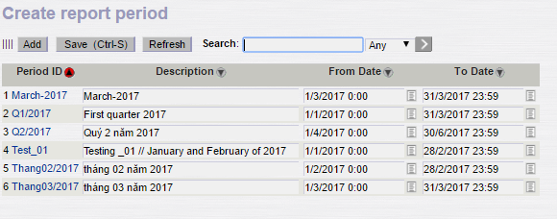
Step 1: Click button

Step 2: Insert information to fileds :
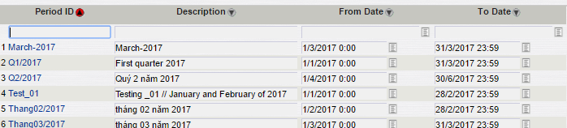

No | Parameter | Description | Insert method | Require | Remark
1 | Period ID | Period name | Mannually | Mandatory
2 | Description | Description for Period ID | Mannually | Mandatory
3 | From date | Started date | Mannually | Mandatory
4 | To date | Ended date | Mannually | Mandatory

+ Period ID: Input variant
Ex: Month03_2017
+ Description: Input description
Ex : Data in month 03 year 2017
+ From date: Input From date
Ex : 01/03/2017 0:00
+ To Date: Input To date
Ex: 31/03/2017 23:59
Step 3: Click button
- Upload data to the created period
Pathway: Corporate Reports / View Corporate Reports

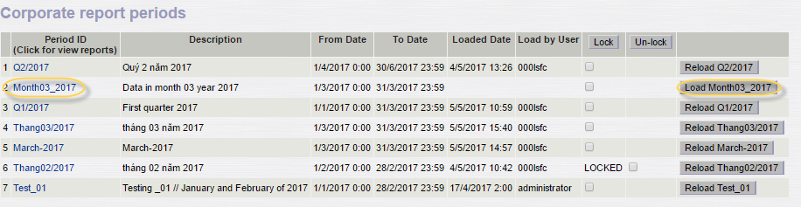

Looking to the variant needs load data which was generated at a – Creat report period
Click on the text “load + variant”.
Wait until the software automatically updated data according to parameters has been declared.
If end users changed the report data, click Reload to update the data.

- Lock/Unlock data
Lock the data: Perform 2 steps as follows:
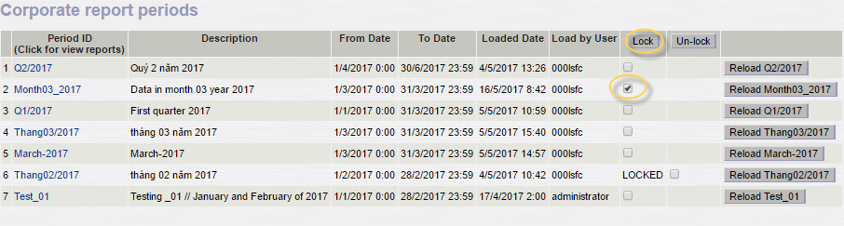
Step 1: Selection
Step 2: Click
Note: “Lock” means can not Reload the data.

Unlock the data: Perform 2 steps as follows 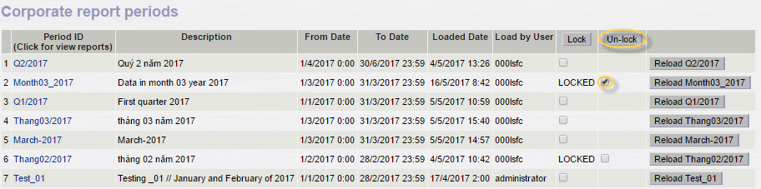
Step 1: Selection
Step 2: Click

Account balances

Purpose
Account balance is the report showed opening, incurred and closing balances of the seleced or all balances.

Performance instruction

Pathway
Path | Accounting/Corporate reports/View Corporate Reports/Accounts balance

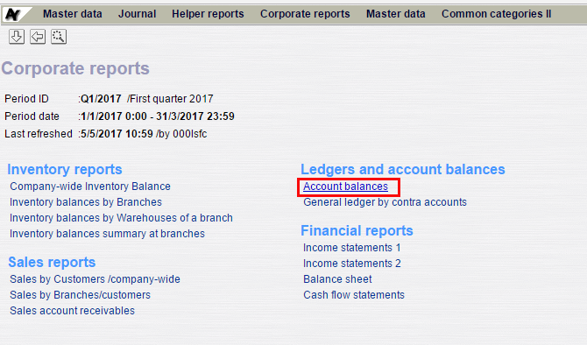

Performance condition
Users have created the period of report, refer to 1.3 General function.

Input parameter
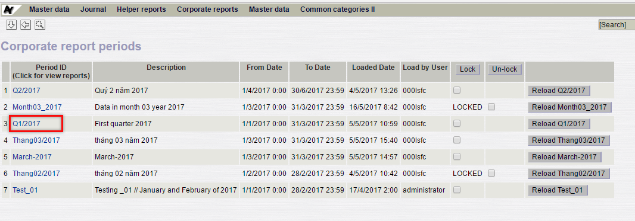

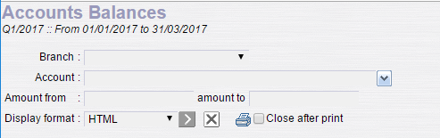

No | Parameter | Description | Condition | Require | Remark
1 | Branch | Company code | Blank or select value from 100 to 207 |  | Blank means all company codes
2 | Account | Account to be showed balances | Blank or select from the list |  | Blank means all accounts
3 | Amount from  Amount to | Filter by amount | Blank or insert a number |  | Blank means not filted
4 | Display format | Output form: HTML, Excel or PDF | Select from the list |  | Default is “HTML”

Report/Form layout
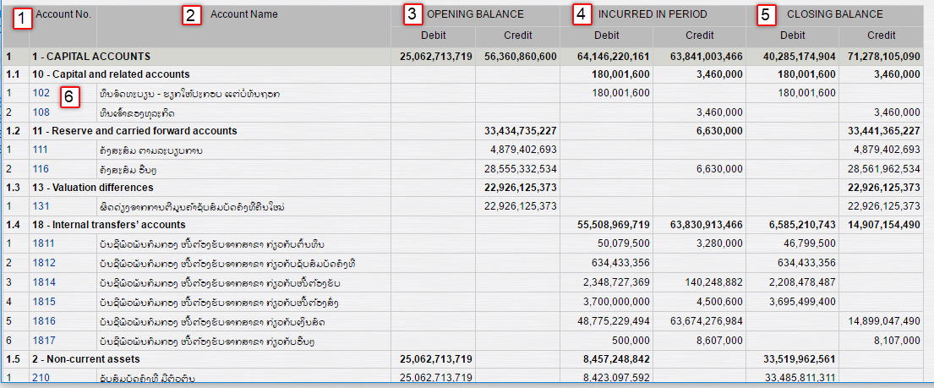

No. | Ref# | Field name | Description
1 | (1) | Account No. | Account number
2 | (2) | Account Name | Acount name is in accordance with account number.
3 | (3) | Opening balance | Opening balance of the accounts has been selected from input parameters. This balance has devide into Debit and Credit side.
4 | (4) | Incurred in period | Incurred in period of the balances has been selected from input parameter. This incurred data has been devide into Debit and Credit also.
5 | (5) | Closing balance | Closing lalance of the accounts has been selected from input parameters. This balance has devide into Debit and Credit side.
6 | (6) |  | Account group

general ledger by contra accounts

Purpose
This general ledger is the report showed opening, incurred and closing balances of the selected balance by one or all contra accounts

Performance instruction

Pathway
Path | Accounting/Corporate reports/View Corporate Reports/General ledger by contra account

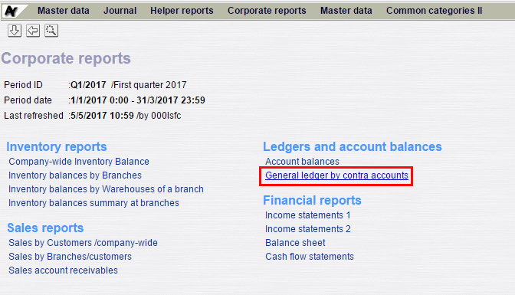

Performance condition
Users have created the period of report, refer to 1.3 General function

Input parameter
No | Parameter | Description | Condition | Require | Remark
1 | Branch | Company code | Blank or select value from 100 to 207 | Not mandatory | Blank means all company codes
2 | Account | Account to be showed balances | Blank or select from the list | Mandatory
3 | Contra account | Account corresponds to the account selected from Account field | Insert manually | Not mandatory | Blank means all contra accounts
4 | Amount from  Amount to | Filter by amount | Blank or insert a number | Not mandatory | Blank means not filted
5 | Display format | Output form: HTML, Excel or PDF | Select from the list |  | Default is “HTML”

Report/ Form layout
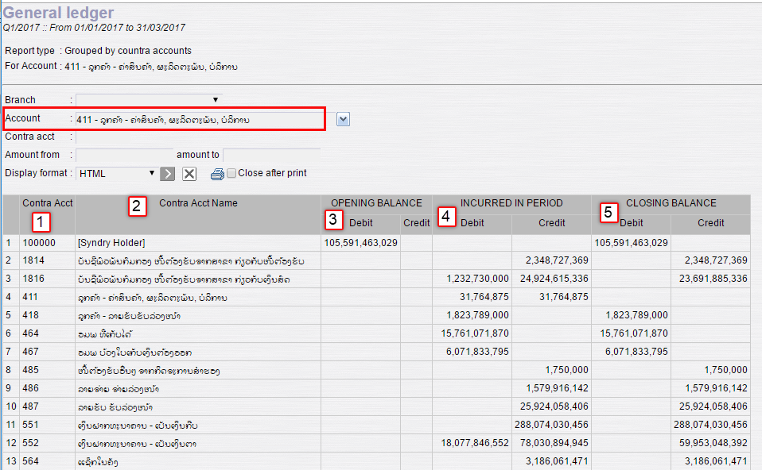

No. | Ref# | Field name | Description
1 | (1) | Contra acct | Account number corespodends to the account has been selected in Account field.
2 | (2) | Contra Account Name | Acount name is in accordance with (1) Contra account number.
3 | (3) | Opening balance | Opening balance of the accounts has been selected from input parameters. This balance has devide into Debit and Credit side.
4 | (4) | Incurred in period | Incurred in period of the balances has been selected from input parameter. This incurred data has been devide into Debit and Credit also.
5 | (5) | Closing balance | Closing lalance of the accounts has been selected from input parameters. This balance has devide into Debit and Credit side.

