PETROLIMEX INFORMATION TECHNOLOGY
AND TELECOMMUNICATION JSC

USER GUIDE
ENTERPRISE RESOURCES PLANNING PROJECT
ENHANCEMENT FUNCTIONAL UPGRADES FOR DATA TRANSFER TO TAXRIS SYSTEM

LSFC-ERP
Created date: 21/03/2022
Latest modified date:
Document code: LSFC-ERP_UG_TAXRIS
Version: 0 01

MỤC LỤC
I. DOCUMENT OVERVIEW 1
2. Acronyms and Abbreviations 1
II. Workflow Process 2
1. Data transmission to TaxRIS system 2
1.1. Purpose of Use 2
1.2. User guide 2
1.2.1. Declare the period of data transmission 2
1.2.2. Sales Data Transfer To TaxRIS 3
1.2.3. Purchase Data Transfer To TaxRIS 4
2. Custom information on ASYCUDA system 5
2.1. Purpose of Use 5
2.2. User Guide 6
2.2.1. Declare Product Code and Brand of the product 6
2.2.2. Declare information on the Custom Declaration 7
3. Product classification 8
3.1. Purpose of Use 8
3.2. Path 8
3.3. Detailed User Guide 8
4. Declare Warehouse ID Code 9
4.1. Purpose of Use 9
4.2. Path 9
4.3. Detailed User Guide 9

DOCUMENT OVERVIEW
- The Scope of the Document
- This document is used to guide end-users to use the function of transfer data to TaxRIS system of Tax Department of MOF (Laos).
- The business processes and workflows are guided in detail, which included: Process overview, data entry steps, explanation of displayed fields.
- When the software is changed or updated, the project team will update the document and its version, specifying which versions and modified the content.
- The completed process is detailed in this document, which could replace the process in the previous version and is confirmed by both parties related.

Acronyms and Abbreviations

Index | Acronyms/Abbreviations | Explanation
 | LSFC | Lao State Fuel Company
 | PIACOM | Petrolimex Information Technology and Telecommunication Joint-Stock Company
 | Tax Department | Tax Department Of The Ministry Of Finance (Laos)
 | TaxRIS | TaxRIS system of The Ministry Of Finance (Laos)
 | ASYCUDA | The Automated System for Customs Data (ASYCUDA)

Workflow Process

Data transmission to TaxRIS system

Purpose of Use
- The process allowed user to select the document created on the LSFC-ERP system built by PIACOM and pull data to the TaxRIS system.

User guide

Declare the period of data transmission

Purpose of Use
- Declare the period of data transmission.

Performance criteria
- Agreement on the data transfer period to the TaxRIS system.

Path
- Logistics/ Reports / Data Transfer to TaxRIS Period

Detailed User Guide
- Go to Base tab id=TaxRisDay or follw the path above to declare the period of data transmission.
- Displayed screen:
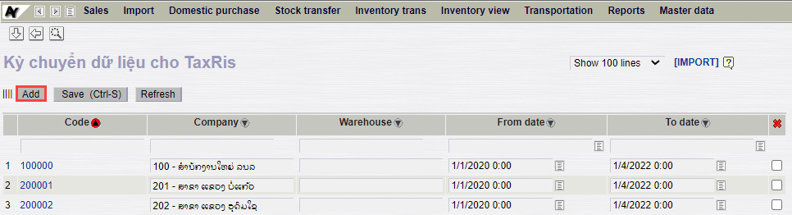
- Select Add to declare new period.
- General information:
Index | Parameter | Decriptions | Information Type | Requied
1 | Code | Period ID code | Input | X
2 | Company | Công ty | Choose in list | X
3 | Warehouse | Mã Kho | Choose in list
4 | From date | Ngày mở kỳ | Choose in list | X
5 | To date | Ngày đóng kỳ | Choose in list | X
- Use shortcut Ctrl + S or choose Save as to save the declared period.

Sales Data Transfer To TaxRIS

Purpose of Use
- Report is used to select documents whose data will be transferred to the TaxRIS system.
- LSFC may integrate and re-transfer any documents that had been edited/deleted after the transmission.

Performance criteria
- Data transfer period has been declared.
- In case of not declaring data transfer period or transfer the data not belong to the period that has been declared, the document data cannot be transferred to TaxRIS the system.

Path
- Logistics/ Reports/ Sales Data Transfer To TaxRIS

Detailed User Guide
- Go to report id=senttaxris or follow the path above to transfer data.
- User selects the warehouse whose document data need to be transferred.
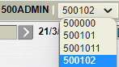
- Parameter declarations
Index | Parameter | Decriptions | Information Type | Requied
1 | From date | Document date | Choose in list | X
2 | To date | Document date | Choose in list | X
3 | Transaction Type | Type of transfer document | Choose in list
- After declare thep parameter, select to run the report.
- The report displays:
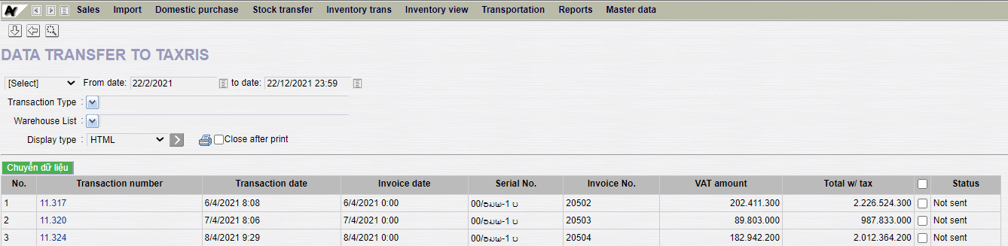
- The user selects the documents they want to transfer in the Status column.
- User selects "Transfer data" to transfer data to TaxRIS.
- After completing the operation, a Pop-up appeared. In this new screen, the user can check which documents have been successfully transferred.
  - Successful Data Transfer: The data has been transferred to TaxRIS.
  - Data Transfer Error: The data encountered an error and could not be transferred to TaxRIS.
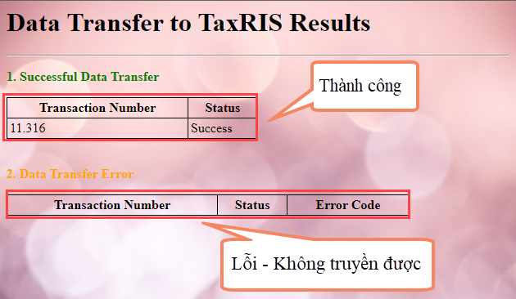

Purchase Data Transfer To TaxRIS

Purpose of Use
- Report is used to select documents whose data will be transferred to the TaxRIS system.
- LSFC may integrate and re-transfer any documents that had been edited/deleted after the transmission.

Performance criteria
- Data transfer period has been declared.
- In case of not declaring data transfer period or transfer the data not belong to the period that has been declared, the document data cannot be transferred to TaxRIS the system.

Path
- Logistics/ Reports/ Purchase Data Transfer To TaxRIS

Detailed User Guide
- Go to report id=senttaxris or follow the path above to transfer data.
- User selects the warehouse whose document data need to be transferred.

- Parameter declarations
Index | Parameter | Decriptions | Information Type | Requied
1 | From date | Document date | Choose in list | X
2 | To date | Document date | Choose in list | X
3 | Transaction Type | Type of transfer document | Choose in list
- After declare thep parameter, select to run the report.
- The report displays:
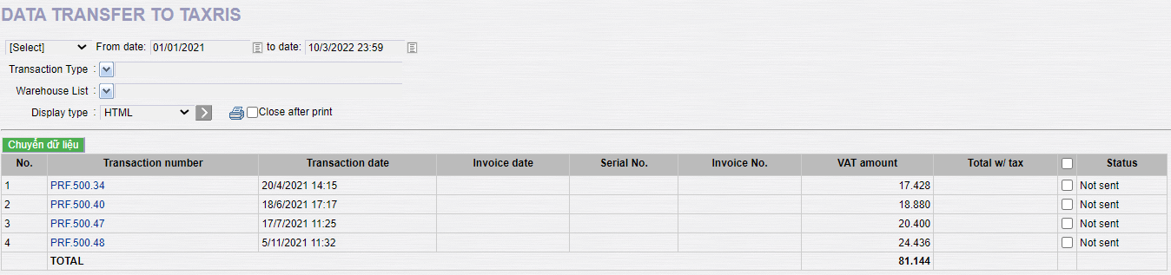
- The user selects the documents they want to transfer in the Status column.
- User selects "Transfer data" to transfer data to TaxRIS.
- After completing the operation, a Pop-up appeared. In this new screen, the user can check which documents have been successfully transferred.
  - Successful Data Transfer: The data has been transferred to TaxRIS.
  - Data Transfer Error: The data encountered an error and could not be transferred to TaxRIS.
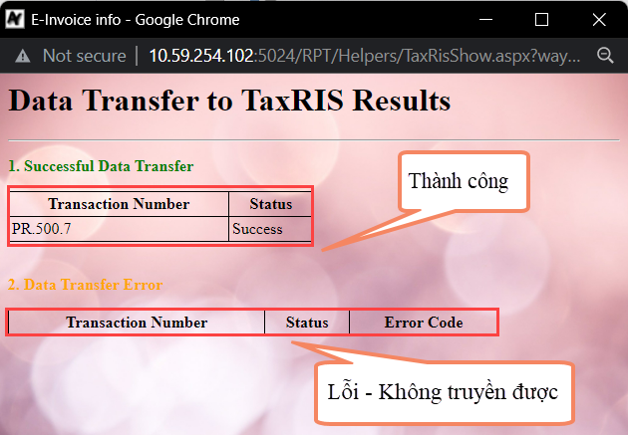

Custom information on ASYCUDA system

Purpose of Use
- In order to meet the demand of transmitting customs information on the ASYCUDA system of the import purchasing service of the Tax Department, PIACOM has added a field to declare the above information.

User Guide

Declare Product Code and Brand of the product

Purpose of Use
- Declare Product Code and Brand of the product for each product.

Performance criteria
- Employee in charged of Import Goods correctly declare Product Code and Brand of the product as ASYCUDA system.
- Product Code and Brand of the product are fixed for each item.

Path
- Logistics/ Master data/ Products

Detailed User Guide
- Go to Base tab id=P1 or follow the path above to transfer data.
- The screen displays:
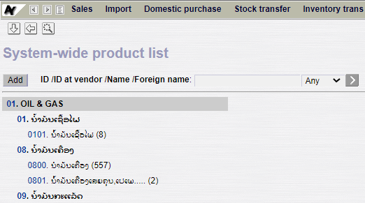
- User selects each item to declare as follows:
  - Product Code: ASYCUDA Product code
  - Brand of the Product: ASYCUDA Brand Name
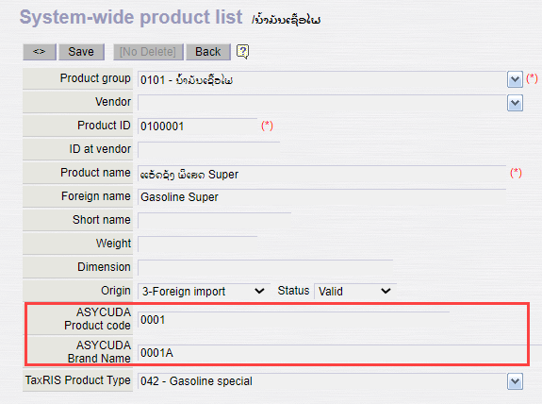
- Use shortcut Ctrl + S or choose Save to save the product information.

Declare information on the Custom Declaration

Purpose
- Declare information about the import border gate, custom declare number and custom declare date.

Performance criteria
- Employee in charged of Import Goods correctly declare the import border gate, custom declare number and custom declare date.

Path
T-code | Path
PR | Logistics/ Import/ Purchase Receipt - Standard stock/ Tab Customs declaration
PRF | Logistics/ Import/ Purchase Receipt - Tax-free stock/ Tab Customs declaration

Detailed User Guide
- Go to T-code PR.PRF or follow the above path.
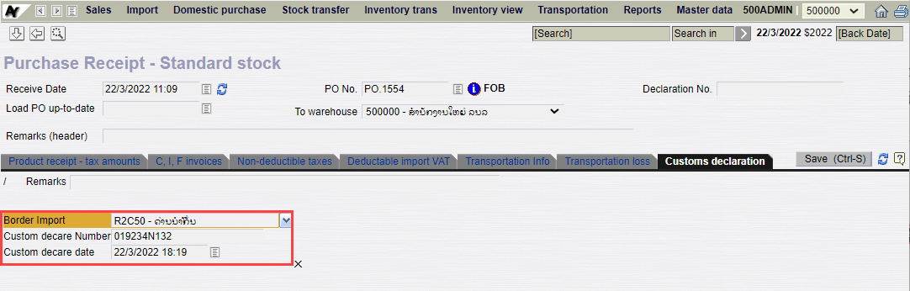
- General information
Index | Parameter | Decriptions | Information Type | Requied
1 | Remarks | Note | Input
2 | Import Border Checkout |  | Choose in list | X
3 | Custom decare Number |  | Input | X
4 | Custom decare date |  | Input or Choose in list | X

Product classification

Purpose of Use
- According to the request of the Tax Department, to classify each product into Product Type, PIACOM has added a field for product classification.

Path
- Logistics/ Master data/ Products

Detailed User Guide
- Go to Base tab id=P1 or follow the above path to classify Product type for each product.
- The screen displays:
- The user select each product to classify them according to the list in TaxRIS Product Type.
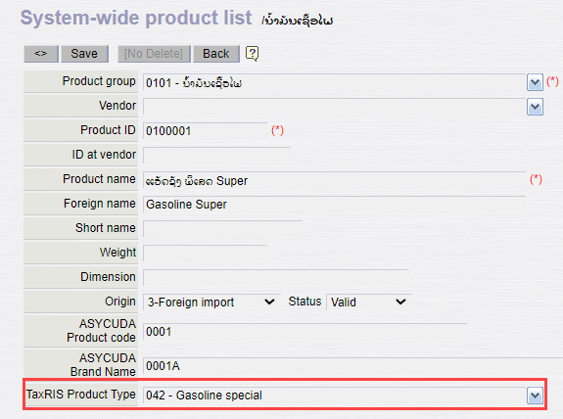
- Use shortcut Ctrl + S or choose Save to save the product information.

Declare Warehouse ID Code

Purpose of Use
- To meet the Tax Department's demand for data transmission of Warehouse Code whose only has up to 5 characters, PIACOM has added a field so that customers can declare a new Warehouse Code according to above-mentioned request.

Path
- Settings/ Enterprise Structure/ Warehouse list

Detailed User Guide
- Go to Base tab id= POS1Auto or follow the above path to declare the warehouse code of each warehouse.
- The screen displays:
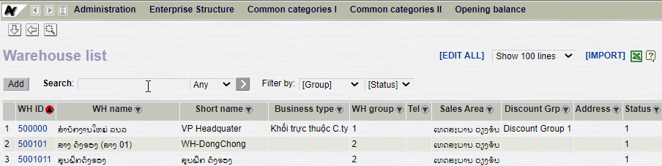
- User selects each warehouse to declare at TaxRis ID.
- Declare each Warehouse ID at TaxRisID.
Rule of Warehouse ID:
<Company code>.<Cardinal numbers>
* Note: Only 5 characters allowed in the above-mentioned field.

